WS B2-1 – ALGORITHM
TOPIC
B2
EFFICIENCY

TIME TO COMPLETE: 1 HOUR

Please show your work, that way I know you’re able to replicate it on the exam.
MAX MARKS: 23
- Determine the Big-O time complexity of the following statements:
  - 3n + 7 [1]

  - 4n² + 2n + 1 [1]

  - 2^{n} [1]

  - Log₂(n) [1]

  - n! [1]

  - n³ + 5n [1]

- Determine the Big-O time complexity of the following algorithms:
  - 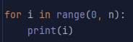 [2]

  - 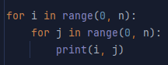 [2]

  - 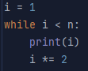 [2]

  - 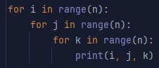 [2]

  - 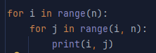 [2]

- Rank the following Big-O time complexities from fastest growing to slowest growing: O(1), O(n), O(logn), O(2^{n}) O(n²) [4]

- Explain why we ignore constants and lower-order terms in Big-O notation [4]

- True or False: O(n + n²) = O(n²) [2]

